G.B.PANT UNIVERSITY OF AGRICULTURE & TECHNOLOGY

College of Technology

Master of Computer Applications



Practical File
for

STRUCTRED PROGRAMMING LANGUAGE
(MCA-614)

Submitted to: - Submitted by: -
Mr’s Shobha Arya Nishant
58041

INDEX
S. No. | Name Of Practical | Signature
01 | Write a C program to find the sum of individual digits of positive integer using while loop.
02 | Write a program to print positive integers from 1 to 10 do-while loop.
03 | Write a C program to generate the first n terms of the Fibonacci sequence using for loop.
04 | To find the factorial of a given number using non-recursive function.
05 | Write a C program to find the factorial of a given integer using recursion.
06 | Write a program to find biggest among three numbers using pointer.
07 | Write a program to insert 5 elements into an array and print the elements of the array.
08 | Write a C program to create database of students belonging to MCA department. The elements of the database are department name, year of establishment, head of department, student name, id, and semester. The program store information of 5 students in structure and display it.
09 | Write a C program to create database of students. The elements of the database are student name, university name, semester, branch. The program stores information about 5 students and display the student name and university name of all students by calling the display function.
10 | write a c program to display the contents of a file.

01.Write a C program to find the sum of individual digits of positive integer using while loop.
Sol –
#include<stdio.h>
int main()
{
int n,sum=0,m;
printf("Enter a number:");
scanf("%d",&n);
while(n>0)
{
m=n%10;
sum=sum+m;
n=n/10;
}
printf("Sum is=%d",sum);
return 0;
}

OUTPUT-
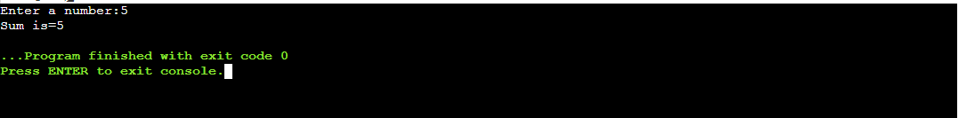

2.Write a program to print positive integers from 1 to 10 do-while loop.
Sol- #include<stdio.h>

int main(){

int num = 1;

int target = 10;

do{

printf("%d\n", num);

++num;

}while (num <= target);

return 0;
}
OUTPUT-
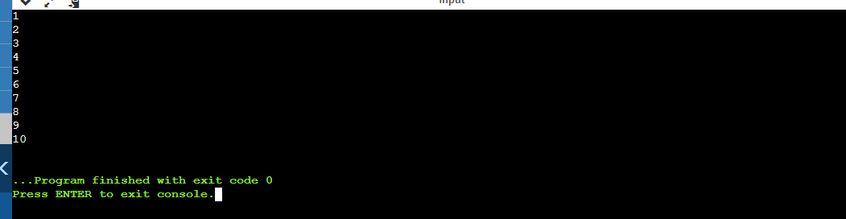

3- Write a C program to generate the first n terms of the Fibonacci sequenceusing for loop.
SOL- #include <stdio.h>
int main() {

int i, n;

int t1 = 0, t2 = 1;

int nextTerm = t1 + t2;

printf("Enter the number of terms: ");
scanf("%d", &n);

printf("Fibonacci Series: %d, %d, ", t1, t2);

for (i = 3; i <= n; ++i) {
printf("%d, ", nextTerm);
t1 = t2;
t2 = nextTerm;
nextTerm = t1 + t2;
}

return 0;
}

OUTPUT-
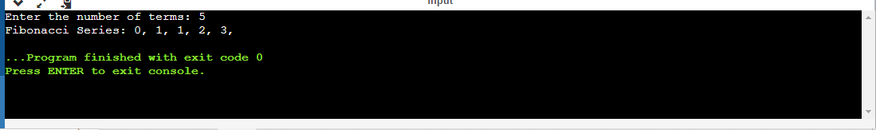

4- To find the factorial of a given number using non-recursive function.
Sol-
#include<stdio.h>
int main()
{
int n,fact=1;
printf("Enter the number for factorial=");
scanf("%d",&n);

for(int i=1;i<=n;i++)

{fact=fact*i;
}
printf("The factorial is =%d",fact);
return 0;
}
OUTPUT-
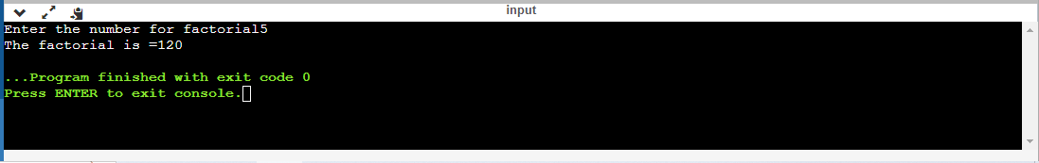

5- Write a C program to find the factorial of a given integer using recursion.
Sol-
#include<stdio.h>

long factorial(int n)
{
if (n == 0)
return 1;
else
return(n * factorial(n-1));
}

void main()
{
int number;
long fact;
printf("Enter a number: ");
scanf("%d", &number);

fact = factorial(number);
printf("Factorial of %d is %ld\n", number, fact);
return 0;
}

OUTPUT-
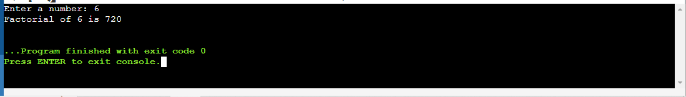

6.Write a program to find biggest among three numbers using pointer.
Sol-
#include <stdio.h>

int main()
{
int a, b, c, *pa, *pb, *pc;

printf("Please Enter three Number to find Largest\n");
scanf("%d %d %d", &a, &b, &c);

pa = &a;
pb = &b;
pc = &c;

if (*pa > *pb)
{
if(*pa > *pc)
{
printf("\nThe Largest Among Three = %d\n", *pa);
}
else
{
printf("\nThe Largest Among Three = %d\n", *pc);
}
}
else
{
if(*pb > *pc)
{
printf("\nThe Largest Among Three = %d\n", *pb);
}
else
{
printf("\nThe Largest Among Three = %d\n", *pc);
}
}
}

OUTPUT-
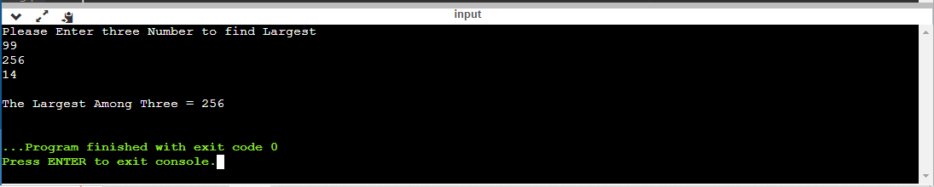

7- Write a program to insert 5 elements into an array and print the elements of the array.
Sol-
#include <stdio.h>

int main()
{

int arr[10] ,n;
printf("Enter the elements to print=");
scanf("%d",&n);
printf("enter the array = \n");
for(int i=0;i<n;i++)
{
scanf("%d",&arr[i]);
}

printf("Elements of given array: \n");

for (int i = 0; i<n; i++) {
printf("%d", arr[i]);
}

return 0;
}
OUTPUT-
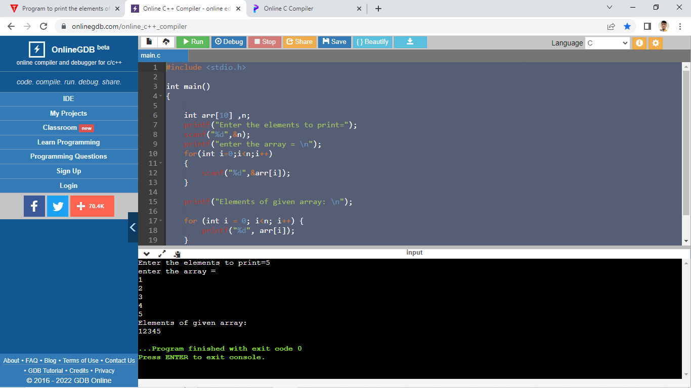

8- Write a C program to create database of students belonging to MCA department. The elements of the database are department name, year of establishment, head of department, student name, id, semester. The program store information of 5 students in structure and display it.
Sol- #include <stdio.h>
int main(){
struct student{
char dept_name[40],hod[40],stud_name[40];
int year_of_estd,id,sem;
} s[10];
printf("Enter information of 5 students as :\nDepartment\tHead of Department\tYear of establishment Department\tName of student\tID\tsem\n");
for(int i=0;i<5;i++)
scanf("%s%s%d%s%d%d",s[i].dept_name,s[i].hod,&s[i].year_of_estd,s[i].stud_name,&s[i].id,&s[i].sem);
printf("Entered information :\n");
printf("Department\tHead of Department\tYear of establishment Department\tName of student\tstudent ID\tsem\n");
for(int i=0;i<5;i++)
printf("%10s\t%18s\t%32d\t%15s\t%10d\t%3d\n",s[i].dept_name,s[i].hod,s[i].year_of_estd,s[i].stud_name,s[i].id,s[i].sem);
return 0;
}
OUTPUT-
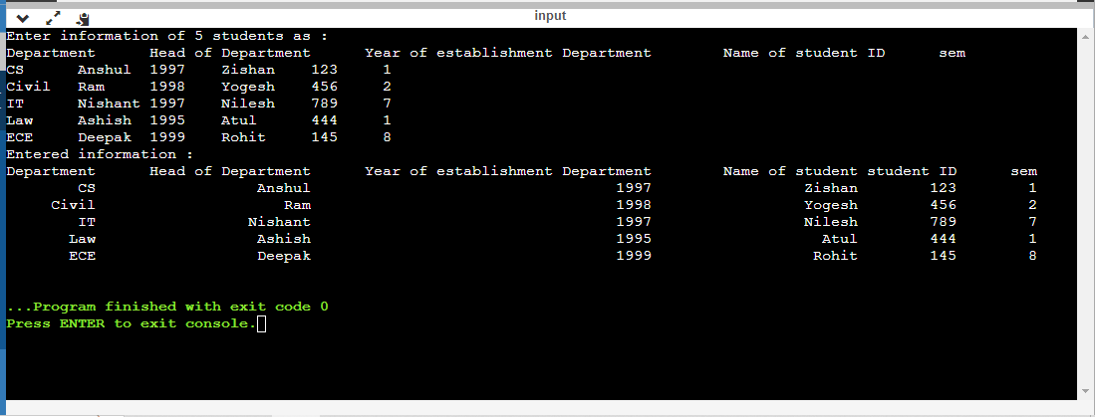
9- Write a C program to create database of students. The elements of the database are student name, university name, semester, branch. The program stores information about 5 students and display the student name and university name of all students by calling the display function.
Sol-
#include <stdio.h>
struct student{
char dept_name[40],hod[40],stud_name[40];
int year_of_estd,id,sem;
} s[10];
void display(struct student s){
printf("%10s\t%18s\t%32d\t%15s\t%10d\t%3d\n",s.dept_name,s.hod,s.year_of_estd,s.stud_name,s.id,s.sem);
}
int main(){
printf("Enter information of 5 students as :\nDepartment\tHead of Department\tYear of establishment Department\tName of student\tID\tsem\n");
for(int i=0;i<5;i++)
scanf("%s %s %d %s %d %d",s[i].dept_name,s[i].hod,&s[i].year_of_estd,s[i].stud_name,&s[i].id,&s[i].sem);
printf("Entered information :\n");
printf("Department\tHead of Department\tYear of establishment Department\tName of student\tstudent ID\tsem\n");
for(int i=0;i<5;i++)
display(s[i]);
return 0;
}

OUTPUT-

10. Write a c program to display the contents of a file

Soln-
#include <stdio.h>
int main(){
FILE *f;
char ch;
f=fopen("file.txt",r);
if (f!=NULL){
printf("File content :\n");
do{
ch=fgetc(f);
printf("%c",ch);
}while(ch=!EOF);
}
fclose(f);
return 0;
}

Output-

